TASK # 02
Zain Ali (323)
Question 01:
Extend the Model-Based Reflex Agent to also control an air-conditioner (turn AC on above 26°C, off otherwise) using the same internal-state pattern
What I did:
I created a Python program using a class called `Agent` to control an air conditioner based on the temperature. The `__init__()` method sets the initial AC status to **“OFF.”** I then created an `act()` method that checks the temperature. If the temperature is greater than 26 degrees, the AC turns **“ON.”** Otherwise, it remains **“OFF.”** Finally, I created an `Agent` object and tested it with temperatures of 18, 28, and 25 degrees. The program displays the AC status for each temperature.
Code :
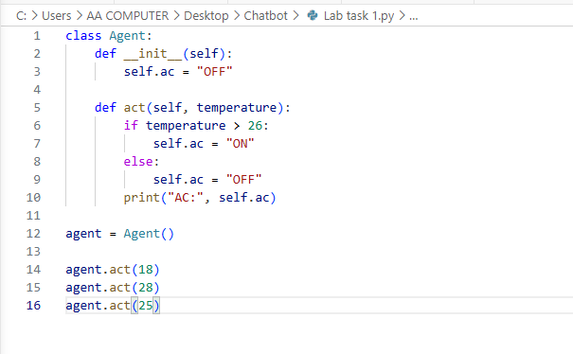
Explanation :
This code creates an `Agent` class that controls an air conditioner based on the temperature.

- The `__init__()` method sets the initial AC status to **“OFF.”**
- The `act()` method takes the temperature as input.
- If the temperature is greater than `26`, the AC is turned **“ON.”**
- If the temperature is `26` or lower, the AC remains **“OFF.”**
- The `print()` statement displays the current AC status.

The program tests three temperatures:

```python
agent.act(18) # AC: OFF
agent.act(28) # AC: ON
agent.act(25) # AC: OFF
```

### Output:

```text
AC: OFF
AC: ON
AC: OFF
```

In short, the program automatically turns the AC on when the temperature is above 26 and turns it off when the temperature is 26 or lower.
Screenshot code running:
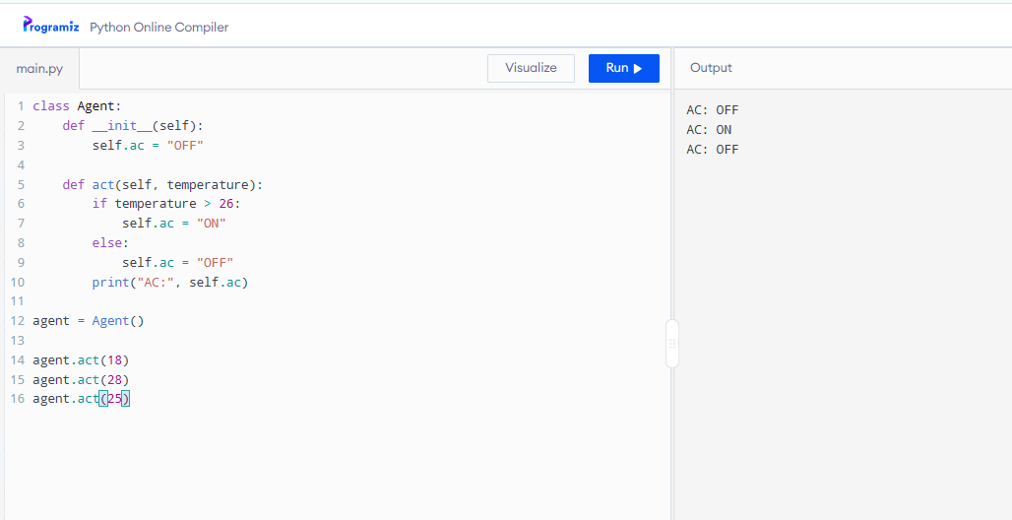
Question 02:
Trace through your agent by hand for the sequence of temperatures [18, 22, 25, 25, 19] and confirm the printed actions match your expectation before running the code.
What I did:
I created a Python program that stores several temperatures in a list called `temperatures`. Then, I used a `for` loop to check each temperature one by one. If a temperature is greater than 26, the program prints **“AC ON.”** Otherwise, it prints **“AC OFF.”** The program displays the AC status for every temperature in the list.
Code :
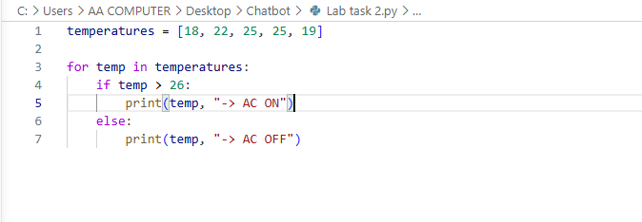
Explanation :
This code checks a list of temperatures and decides whether the air conditioner should be **ON** or **OFF**.

```python
temperatures = [18, 22, 25, 25, 19]
```

This creates a list containing five temperature values.

```python
for temp in temperatures:
```

This `for` loop goes through each temperature in the list one by one. The variable `temp` stores the current temperature.

```python
if temp > 26:
print(temp, "-> AC ON")
```

If the temperature is greater than 26, the program prints that the AC is **ON**.

```python
else:
print(temp, "-> AC OFF")
```

If the temperature is 26 or lower, the program prints that the AC is **OFF**.

### Output:

```text
18 -> AC OFF
22 -> AC OFF
25 -> AC OFF
25 -> AC OFF
19 -> AC OFF
```

All the temperatures are 26 or lower, so the AC remains **OFF** for every value.
Screenshot code running:
